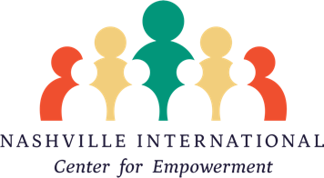

Health Intern

Nashville International Center for Empowerment, established in 2005, is a nonprofit 501(c)(3) community-based organization dedicated to ensuring refugees and immigrants achieve their full potential now and for generations to come.

Title of Position: Health Intern

Purpose: The Health Intern will primarily support intensive case management, health education, and mental health care coordination services for vulnerable refugee and immigrant populations; and will also help carry out projects related to refugee health and wellness.

Commitment: Minimum of 15 - 30 hours per week; specific schedule to be negotiated with supervisor.

Duties:
- Demonstrate knowledge of the refugee resettlement process; local and national stakeholders in refugee health services; and the barriers that refugees may experience while interacting with government entities, healthcare organizations, and social work professionals.
- Achieve fluency in intensive case management procedures such as client intake, documentation of referrals, streamlining referral processes, and case closure
- Analyse intake forms, progress forms, and exit forms across all NICE programs for opportunities for mental health referrals and tracking holistic wellbeing outcomes
- Create exit interviews with mental health related information
- Support the compilation of diaspora community connections / networking into a usable resource for NICE staff
- Provide needs assessments of diaspora communities capacity for mental health related information/referrals
- Implement Nashville-Neighbours style program of health-education for higher need clients with chronic disease (asthma, diabetes, etc)
- Streamline administrative needs for health education (health care navigation and maternal health)
- Create and implement organizational/administrative tools for health education service provisions (organizing partner lists, event calendar organization, etc)
- Receive thorough feedback from program managers
- Other duties as assigned
Requirements:
- Excellent written and oral English proficiency
- Advanced computer and typing skills
- Reliable transportation
- Commitment to adhering to agreed-upon schedule
Preferences: Activities for the program will be completed at the NICE office. Specific modifications can be made in discussion with the Director of Health.
Location: 417 Welshwood Dr., Nashville, TN 37211
Supervisor: This position reports to the Director of Health

To apply, please fill out the Internship Application, and direct any questions to the Volunteer & Training Coordinator at volunteer@empowernashville.org.

